Save Big with End-of-Year Discounts on Quickfinder Handbooks! Order and save with National Association of Tax Professionals (NATP)!

Quickfinder Handbooks are your quick reference for common tax questions and insights – the easy-to-understand language, charts and tables answer your questions using various examples that highlight real-life situations. Available in print or eBook, Quickfinder Handbooks work where you do this tax season.
Order now at tax.tr.com/NATP or use code Q680 and save up to 20% off!
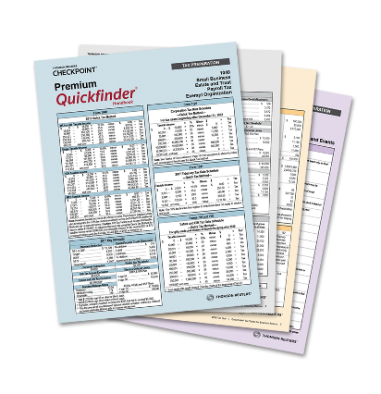 |  | Buy any 1 Save 5%  Buy any 2 Save 7%  Buy any 3 – 5 Save 12%  Buy any 6 – 10 Save 15%  Buy any 11 – 20 Save 17%  Buy any 21+ Save 20% (Best Savings!)
Savings of up to 20% applies to new orders place by April 14, 2021. Savings promotion excludes Checkpoint, RIA, PPC, and Checkpoint Learning CPE and may not be combined with any other offers. Please call 1-800-431-9025 and mention National Association of Tax Professionals (NATP) or visit tax.tr.com/NATP to order.

New! Save 10% on all new purchases of PPC/RIA Print Publications with promotion code PRINT10.*
With the new legislation, PPC and RIA publications are a valuable resource for additional guidance to help you proactively identify solutions to better serve your client’s unique needs in these challenging times. Choose from over 80 titles to best meet your practices needs. Call 1-800-431-9025 Option 1, and then Option 2 to speak with your local sales representative or use promotion code PRINT10 when purchasing online at tax.tr.com/ppc.
*Savings of up to 10% applies to new PPC/RIA Print orders placed by December 30, 2020. Savings promotion excludes Checkpoint, Quickfinder, and Checkpoint Learning CPE and may not be combined with any other offers.

